SYMPTOTRACKAI: HYBRID RAG BASED SYMPTOM TRACKING AND HEALTH MONITORING SYSTEM
Design and Implementation
Department of Computer Science and Engineering, TKR College of Engineering & Technology
Batch C12 (CSE-C) · Academic year [ACADEMIC YEAR]
Table 1: Project team
S.No. | Student name | Roll number
1 | Mariyada Karthika Reddy | 23K91A05E9
2 | Nacharam Akshaya | 23K91A05G6
3 | Madoori Prabath Teja | 23K91A05D6
4 | Pulimadhi Keerthan | 23K91A05K1

Project guide: Dr. Ch. B. Naga Lakshmi
Chapter and section numbers quoted in the text (for example Chapter 8 or Section 6.2) refer to the full project report, 17.Final Document. Figures and tables in this document are numbered from 1.

1. DESIGN
This chapter turns the requirements of Chapter 4 into a design. It gives the architecture, the workflow of one symptom analysis, the data flow diagrams, the UML models, the database, the module design, the interface design and the reasons for the main design decisions. The project is named SymptoTrackAI; it is implemented as a web application called CareLens AI, which is the name that appears in the code and on every screen, and the two names are used for the same system. Every diagram was drawn from the code in the repository (app/, scripts/ and frontend/) and each is listed again with a short explanation in the block-diagram document.

1.1 Design Goals and Architecture
Five goals shaped the design. The first is local-first operation: symptoms are health data, so nothing is sent to an external service. The embedding model, the reranker and the generator run on the machine, and the consultations are stored in a local SQLite file. The second is answers grounded in retrieved text: the user is shown the knowledge-base records that the answer was built from, so that the basis of every answer can be inspected. The third is graceful degradation: if a model cannot be loaded the system still answers, using a simpler method, and the label on the answer says which method produced it. The fourth is safety first: a rule layer that is independent of the retrieval models raises an emergency or caution notice, and a permanent disclaimer states that the output is not a diagnosis. The fifth is simplicity of operation: one launcher, one configuration file, one database file.
The architecture has four tiers over a set of local stores. The presentation tier is a React single-page application served by the Vite development server on port 5412. It has eight routes and a thin client module, lib/api.js, which calls the API through fetch and turns every failure into a message that is safe to show. The application tier is a FastAPI service on port 8412; its routers (auth, chat, history, about and the legacy pages) are mounted in app/main.py. It validates input with Pydantic, opens a database session per request, calls the RAG tier and converts errors into JSON responses. The RAG tier, app/rag, holds the working classes; a single object, the Pipeline, orchestrates them for one query. The data tier is SQLite for the users and their consultations, a processed knowledge base in CSV and JSON, a FAISS index with its record list, a BM25 corpus file, and the Hugging Face cache that holds the three model weights.
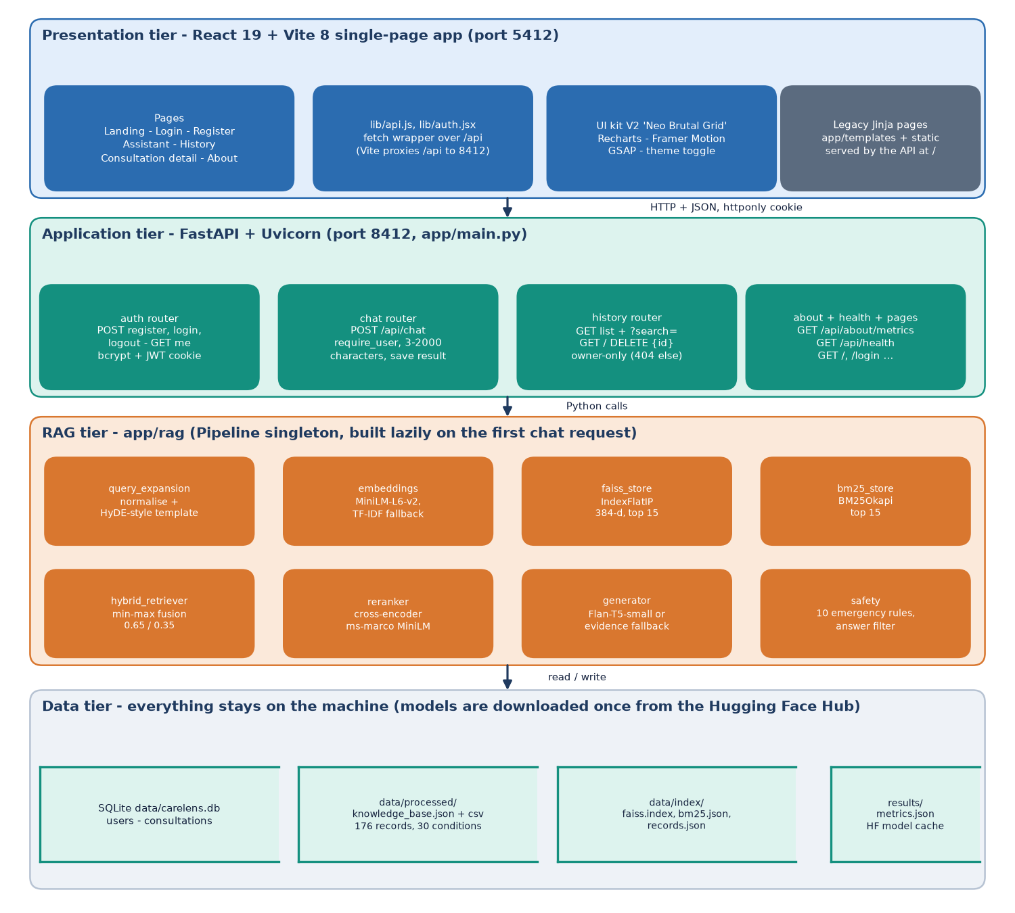
Figure 1: Four-tier architecture of SymptoTrackAI (CareLens AI): React web app, FastAPI application, RAG modules and local data stores.
No external service is used at run time. After the models have been downloaded once, the whole system works offline: if the embedding model cannot be loaded the retrieval uses TF-IDF vectors, if the reranker cannot be loaded the hybrid order is used, and if the generator cannot be loaded an evidence-based answer is composed from the retrieved records. The backend still serves the original server-rendered pages (templates/ and static/, written before the React interface) at the root of the API; they are not the product front door and are not described further.
Table 2: Tiers, technologies and responsibilities
Tier | Technology | Responsibility
Presentation | React 19, React Router 7, Vite 8, Recharts, Framer Motion, GSAP | Landing, sign-in, assistant, history, detail and about pages; theme; loading, empty and error states
Application | FastAPI, Uvicorn, Pydantic v2, SQLAlchemy 2, PyJWT, bcrypt | Routes, input validation, authentication, per-user queries, error handling
RAG | sentence-transformers, FAISS, rank-bm25, Transformers, scikit-learn | Query expansion, embeddings, dense and lexical search, fusion, reranking, generation, safety rules
Data | SQLite, CSV, JSON, FAISS index file, Hugging Face cache | Users, consultations, knowledge base, indexes, model weights

1.2 High-Level Workflow
The workflow of the system is the workflow of one POST /api/chat request. It runs through a fixed sequence of stages. The route checks the sign-in cookie and the length of the message; the Pipeline normalises the text and builds a short hypothetical description from it; the combined text is embedded; FAISS returns the fifteen nearest records and BM25 the fifteen best lexical matches; the two score lists are normalised and fused; the cross-encoder rescores the fused candidates and the best five are kept; a separate rule layer checks the original message for emergency wording; the generator produces the answer text; the answer filter removes listed medication phrases; and the consultation is stored and returned to the interface, which shows the answer, the safety banner and one evidence card per retrieved record.
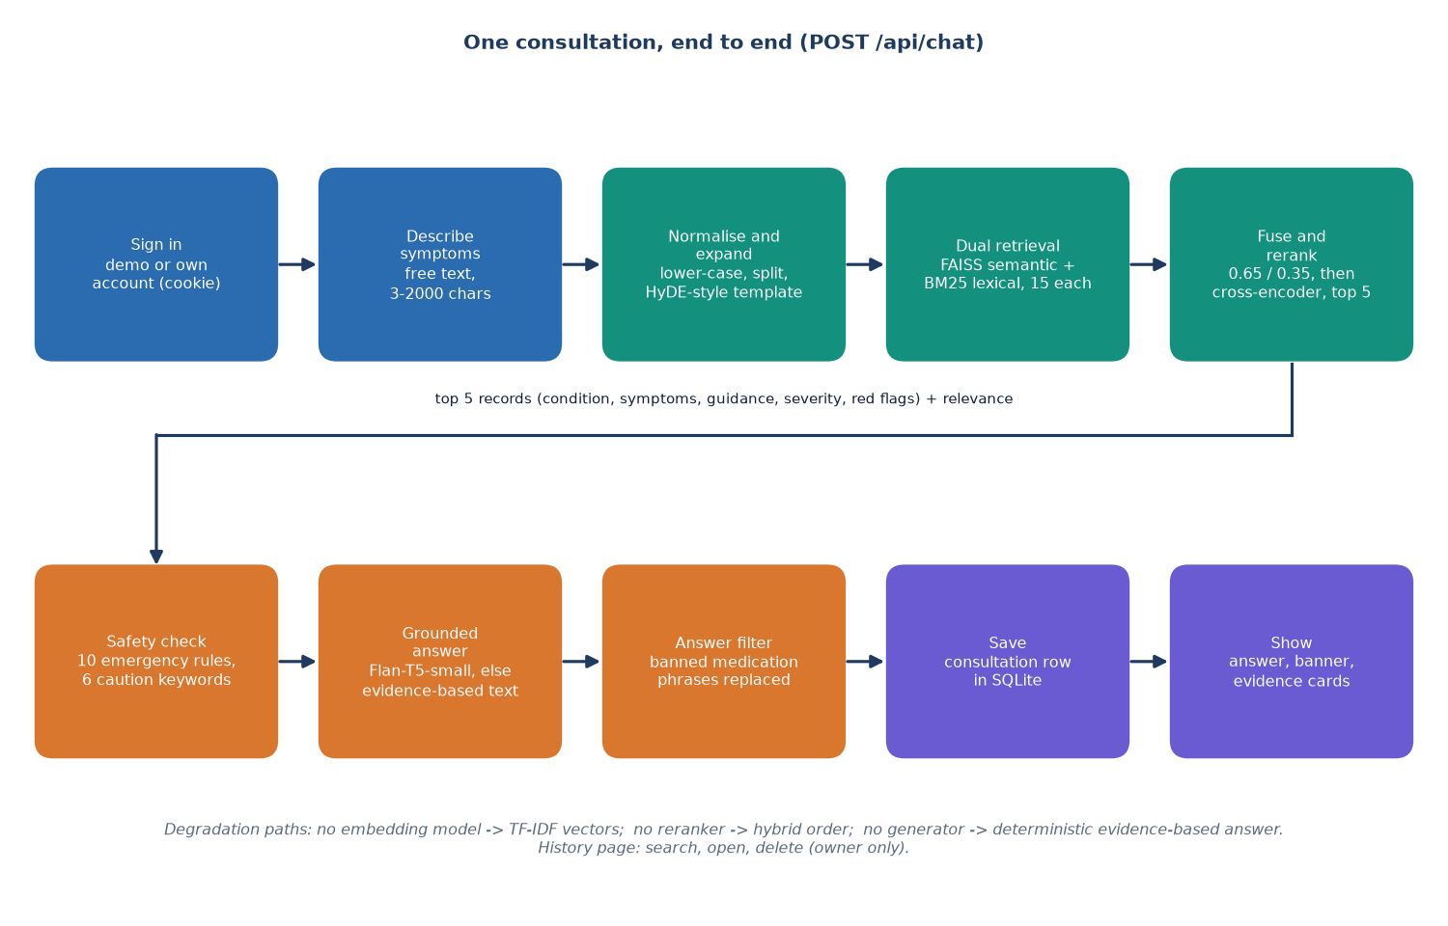
Figure 2: High-level workflow of one symptom analysis (POST /api/chat).
There are three degradation paths. If the sentence-transformer cannot be loaded, the embedding backend switches to a 384-feature TF-IDF vectoriser fitted on the knowledge base. If the cross-encoder cannot be loaded, the hybrid score is used as the rerank score. If the generator cannot be loaded, or fails on a query, Generator.generate returns the deterministic evidence-based answer and labels it evidence-fallback. If the knowledge base or the index is missing the route returns 503 with a message that names the missing file. In all cases the other stages are unaffected.
Offline, the knowledge base is prepared by scripts/prepare_data.py, which writes data/processed/knowledge_base.csv and .json; scripts/build_index.py embeds every record, writes the FAISS index and the BM25 corpus into data/index/, and scripts/seed_demo.py creates the demo account. run.bat runs the three scripts when their outputs are missing. The Pipeline also rebuilds the index itself on first use if the files are absent.
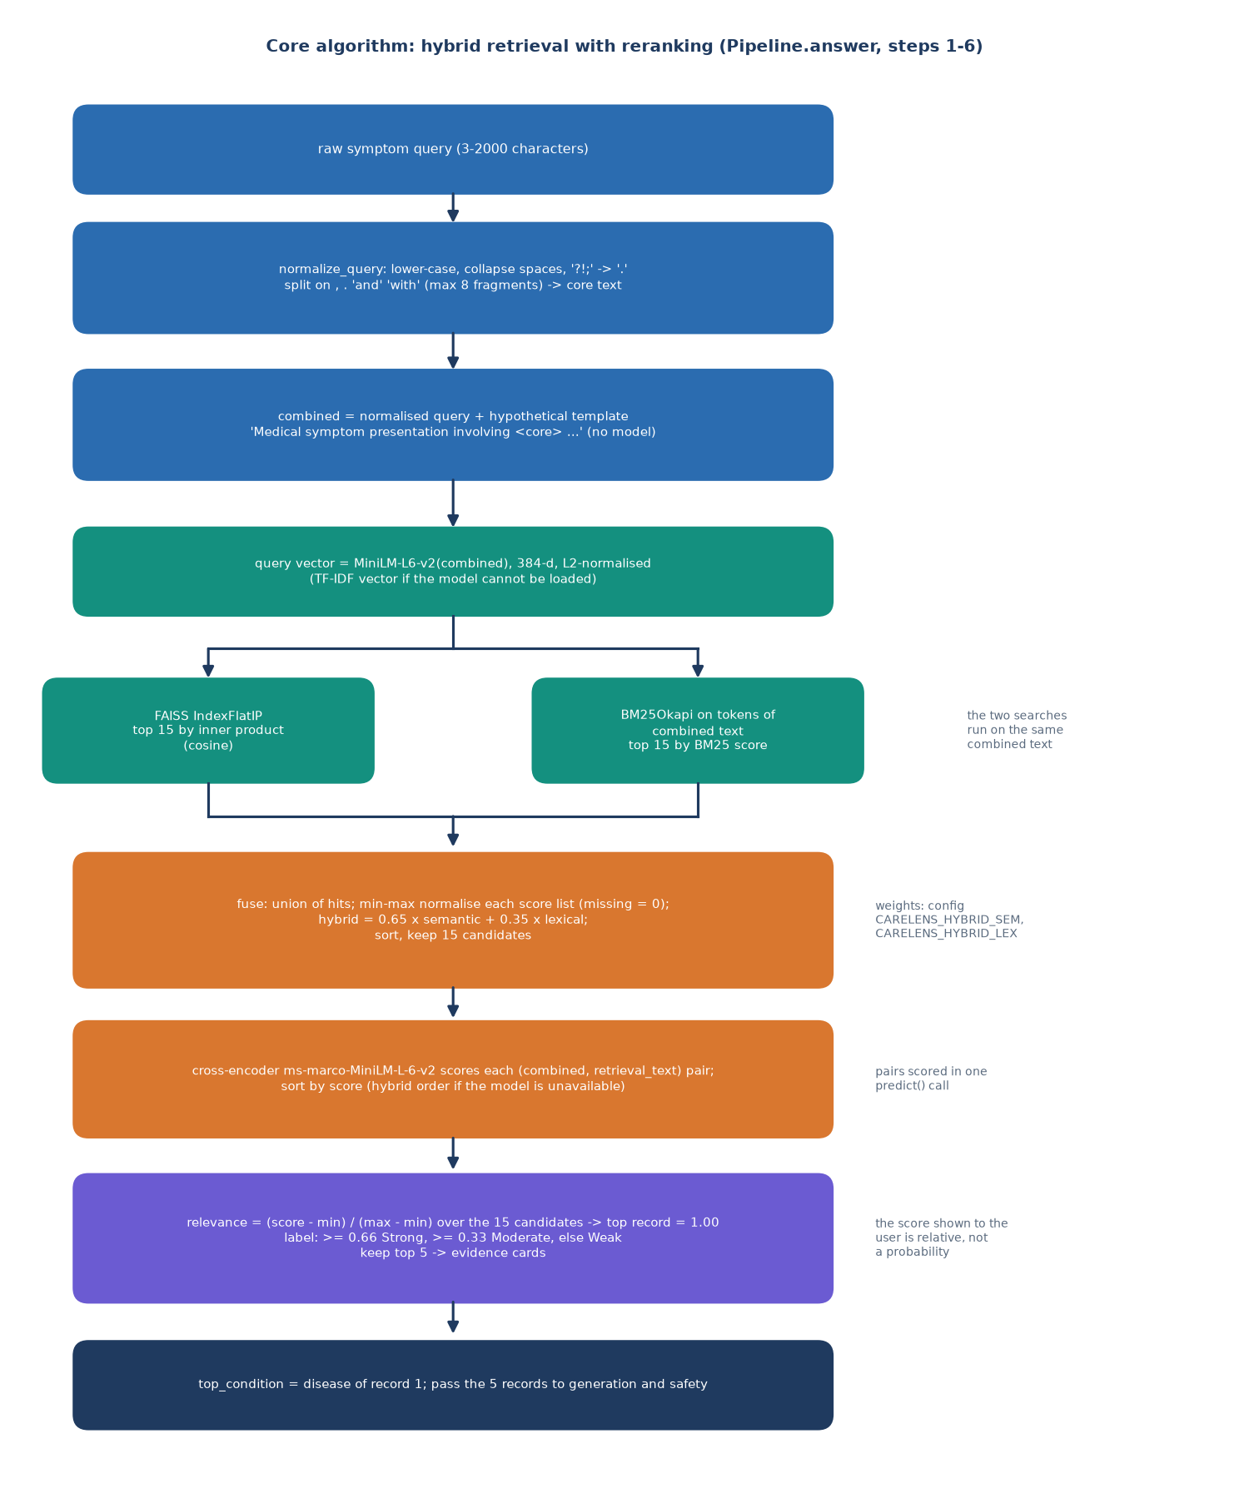
Figure 3: Flowchart of the retrieval algorithm: expansion, dual retrieval, fusion, reranking, safety and generation.
The flowchart above shows the retrieval algorithm at the level of decisions: where the pipeline branches on the availability of a model, and where the safety layer and the answer filter are applied. The decision flow of the safety layer alone is shown below.
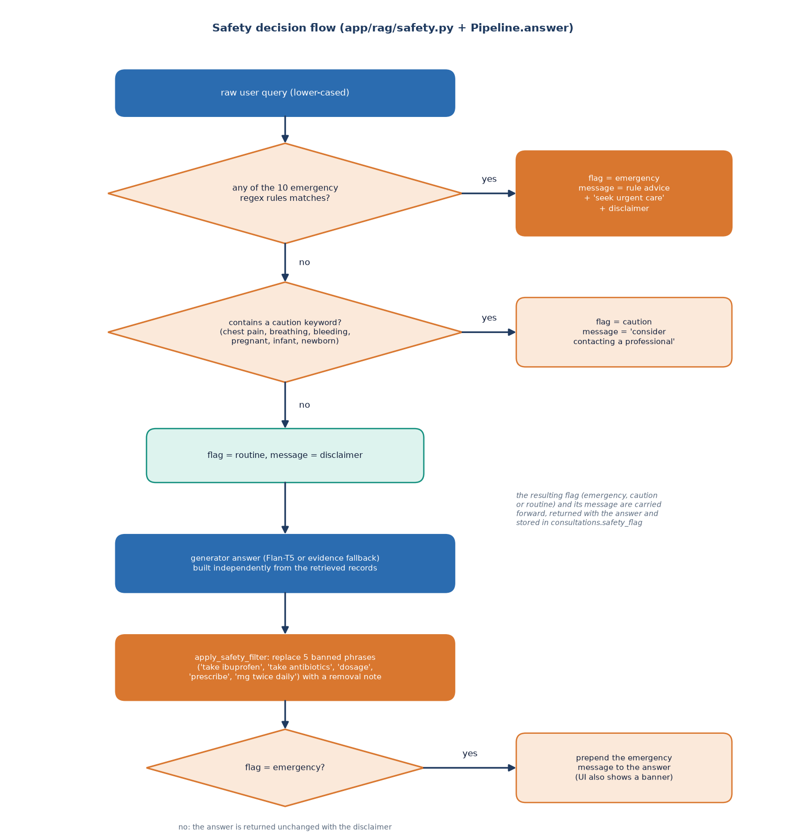
Figure 4: Decision flow of the safety layer and the answer filter.

1.3 Data Flow Diagrams

1.3.1 Level 0: context
At the context level the system is one process with two neighbours. The user sends registration and sign-in details, symptom descriptions, history searches and deletion requests, and receives the grounded answer, the evidence cards, the safety notice, the stored history and the evaluation figures. The Hugging Face Hub is contacted only on the first run, to download the embedding, reranker and generator weights into the local cache; after that no external system exchanges data with the application.
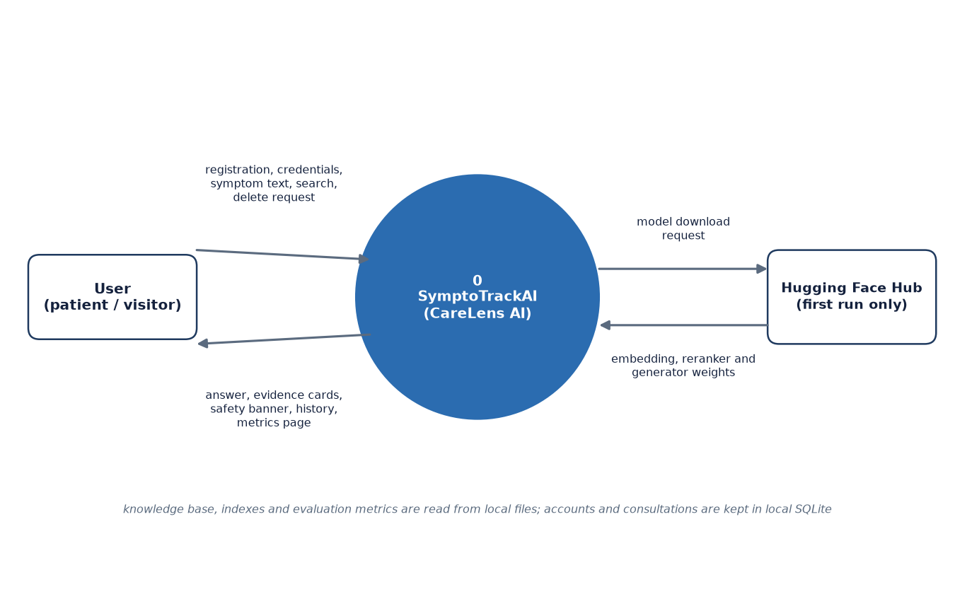
Figure 5: Context diagram (DFD level 0).

1.3.2 Level 1: main processes
Level 1 divides the system into seven processes and four stores. Process 1.0 guards the processes that act on a user's data (2.0, 4.0 and 5.0). The developer appears as a second actor because process 7.0, which builds the knowledge base and the indexes, is run once from the scripts before the application is used. The table gives the data that enter and leave each process.
Table 3: Level 1 processes and their data
No. | Process | Inputs | Outputs | Stores
1.0 | Authenticate user | E-mail, password, session cookie | Session cookie, user id, validation errors | D1 (read, write)
2.0 | Retrieve evidence | Symptom text | Top-5 records with relevance | D2 (read)
3.0 | Generate and screen answer | Original text, top-5 records | Answer text, safety flag and message, evidence cards | -
4.0 | Store consultation | Result of 3.0, user id | New consultation row | D3 (write)
5.0 | Manage history | Search text, consultation id, delete request, user id | History list, detail, deletion result | D3 (read, delete)
6.0 | Report metrics | Metrics request | Stored metrics and knowledge-base size | D4 (read), D2 (size)
7.0 | Build knowledge base and index | Condition table in prepare_data.py | Knowledge-base files, FAISS and BM25 indexes | D2 (write)

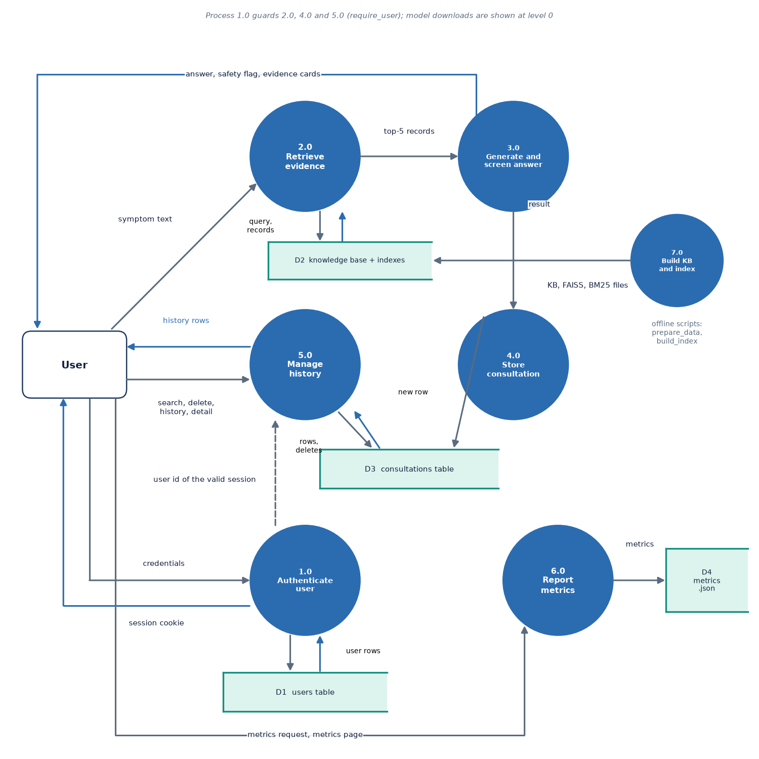
Figure 6: DFD level 1: six processes and three data stores.
The stores are D1, the users table; D2, the knowledge base with its FAISS and BM25 indexes; D3, the consultations table; and D4, the stored metrics file results/metrics.json. Process 5.0 also serves the history search, the detail view and the deletion, all of which are restricted to the signed-in user's own rows.

1.3.3 Level 2: the analysis processes
Level 2 expands processes 2.0 and 3.0 into the steps of Pipeline.answer. Each step takes the output of the previous one; the original message is passed unchanged to the safety check.
Table 4: Level 2 sub-processes
No. | Sub-process | Module and function | Data read
2.1 | Normalise and expand | query_expansion.normalize_query, expand_query_hyde | Symptom text
2.2 | Embed query | embeddings.EmbeddingBackend.encode | all-MiniLM-L6-v2 weights
2.3 | Semantic search | faiss_store.FaissStore.search | data/index/faiss.index
2.4 | Lexical search | bm25_store.BM25Store.search | data/index/bm25.json
2.5 | Fuse (0.65 / 0.35) | hybrid_retriever.fuse | Two lists of 15 hits
2.6 | Cross-encoder rerank | reranker.Reranker.rerank | Cross-encoder weights
3.1 | Grounded answer | generator.Generator.generate | Flan-T5 weights, or the fallback
3.2 | Safety check and filter | safety.check_safety, apply_safety_filter | Original text; answer text

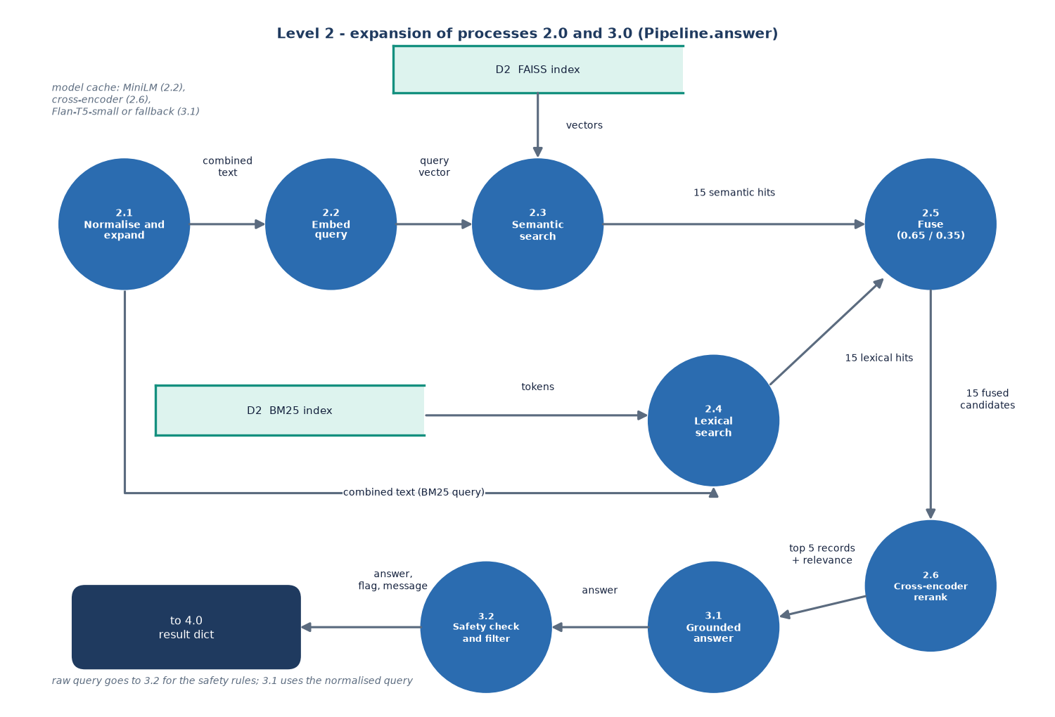
Figure 7: DFD level 2: expansion of the analysis processes into their sub-processes.

1.4 UML Diagrams

1.4.1 Class diagram
The class diagram shows the classes of the system. Two are persistent: User and Consultation, the SQLAlchemy classes that map to the two tables, joined by a one-to-many relationship with cascade delete. The Pydantic schemas (RegisterRequest, LoginRequest, ChatRequest, EvidenceItem, ChatResponse) state the limits of every input and the shape of the output. The routers are thin: each function validates, calls one collaborator and returns a dictionary. The Pipeline owns one object of each RAG class: EmbeddingBackend, FaissStore, BM25Store, Reranker and Generator. Safety is a module of two functions rather than a class, and hybrid_retriever is a module with the single function fuse.
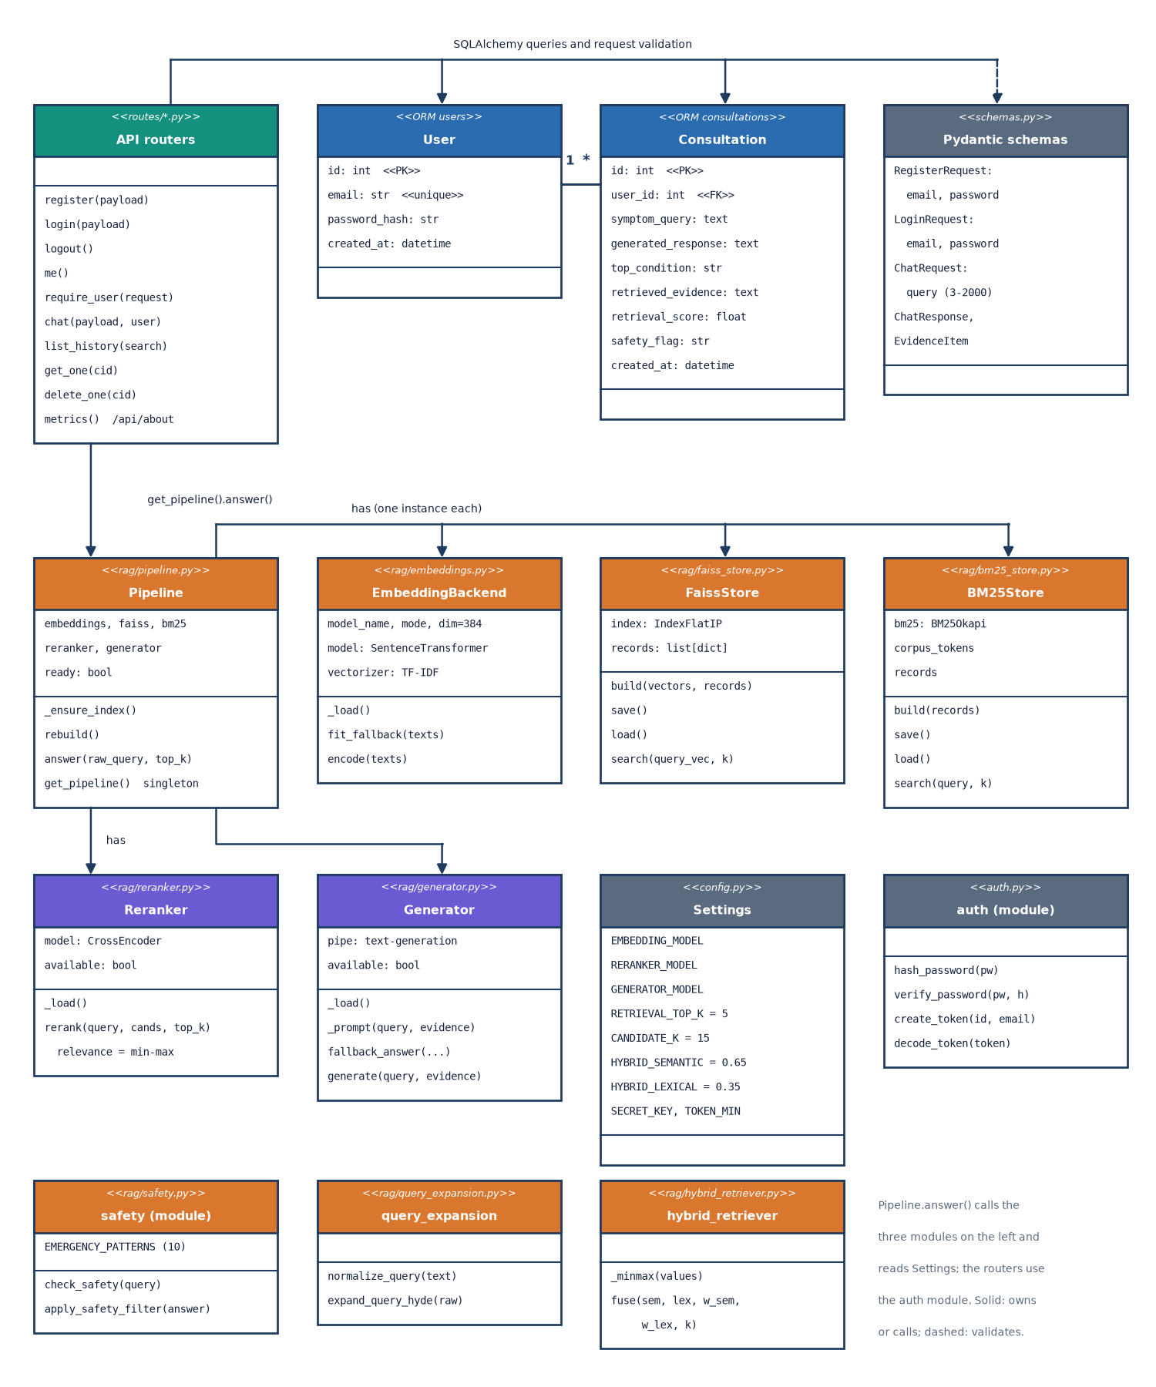
Figure 8: UML class diagram: ORM classes, schemas, routers and the RAG classes.

1.4.2 Sequence diagram
The sequence diagram follows one symptom message. The browser posts the text to /api/chat; the route resolves the user from the cookie, calls Pipeline.answer and then stores a Consultation row before it returns the response. Inside the Pipeline the order of calls is expansion, embedding, FAISS, BM25, fusion, reranking, safety check, generation and filtering. The interface then adds the answer to the conversation, shows a confirmation toast and reloads the list of recent consultations.
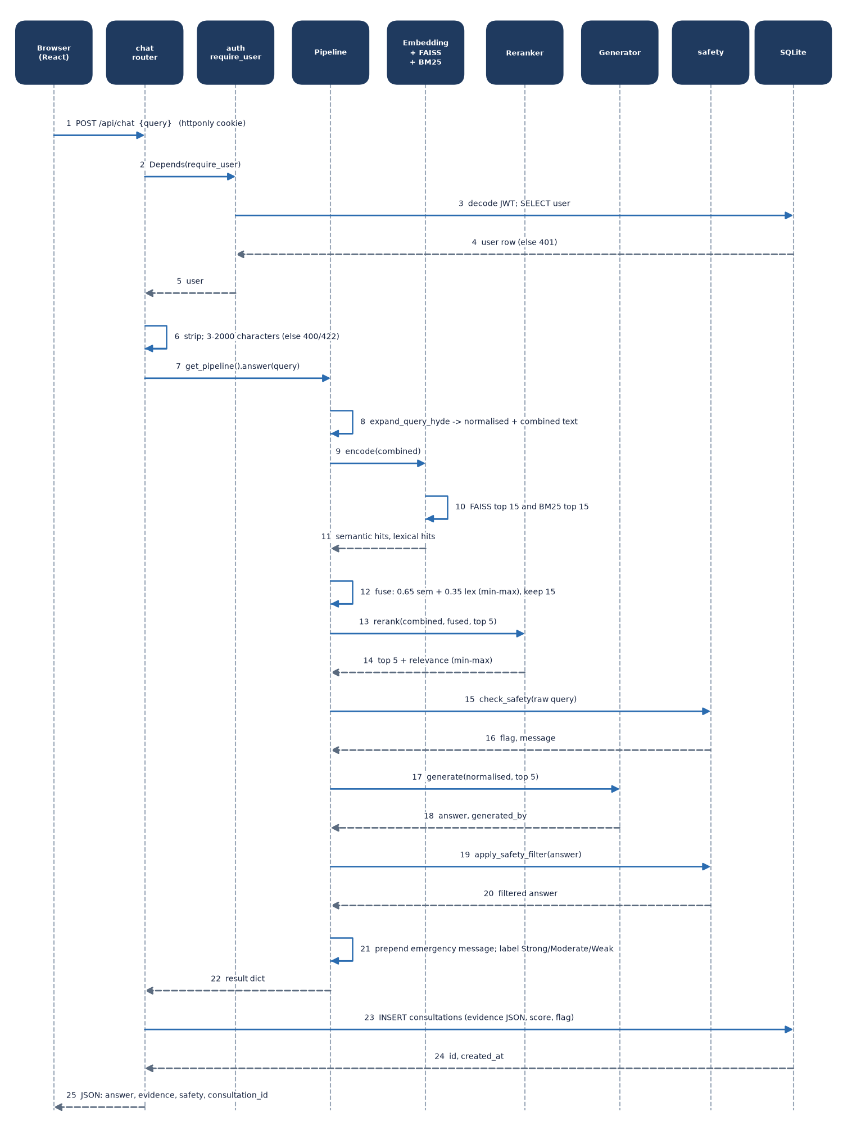
Figure 9: Sequence diagram of the main flow: one symptom message from the browser to the stored answer.

1.4.3 Use-case diagram
Two human actors use the system. A visitor who is not signed in can open the landing page, register and sign in with an own or the demo account. A registered user can in addition describe symptoms, read the grounded answer and its evidence cards, see the emergency or caution banner (part of reading the answer), see the recent consultations, search the history, open a consultation, delete it, view the About page with the measured metrics, and sign out or switch the theme. The local models (MiniLM, the reranker and Flan-T5) take part as a system actor in reading the answer. Every use case from UC4 onwards needs a valid session cookie. The table below lists the use cases with their pre-conditions.
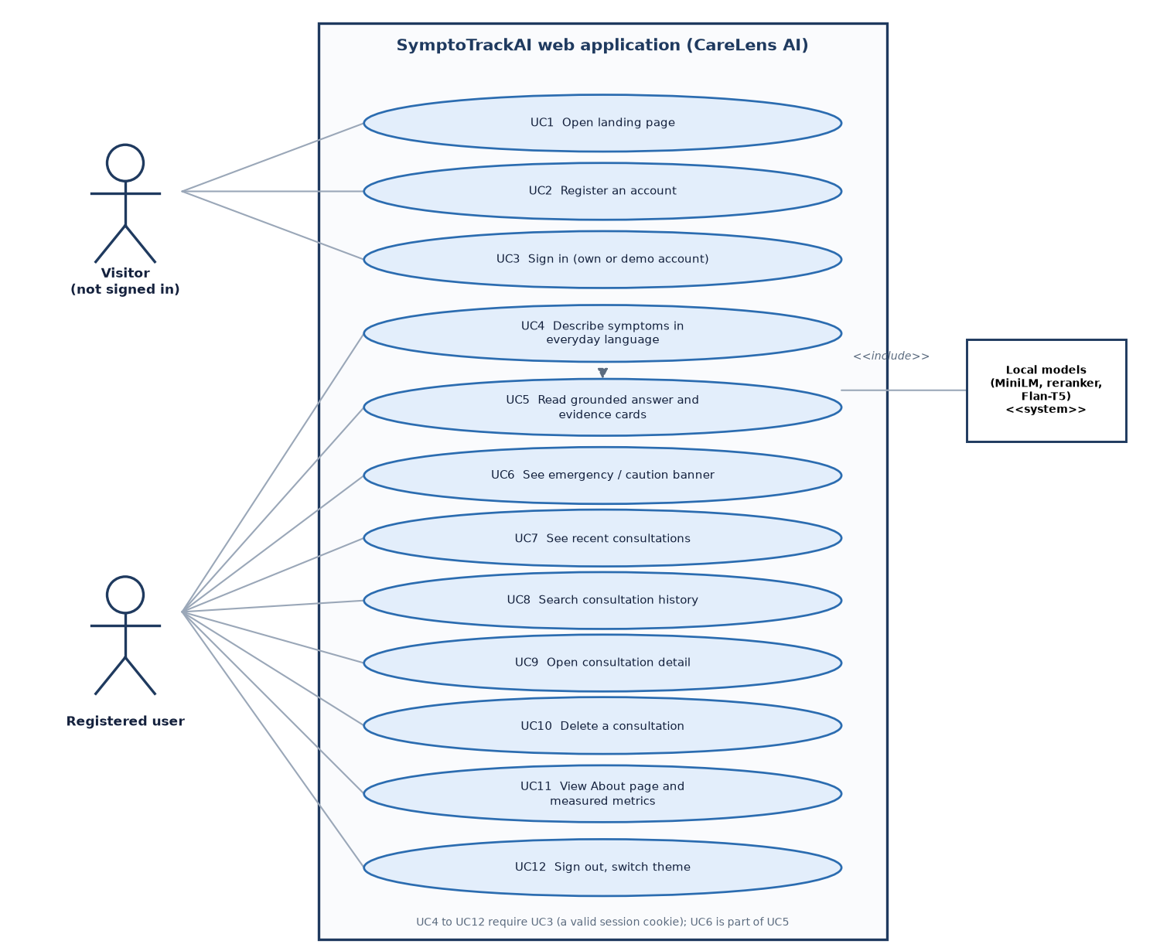
Figure 10: Use-case diagram of the visitor and the registered user.
Table 5: Use cases
No. | Use case | Actor | Pre-condition | Main result
UC1 | Open landing page | Visitor | - | Product pitch and links to register or the demo login
UC2 | Register an account | Visitor | E-mail not yet used; password of 6 to 128 characters | Account created and signed in
UC3 | Sign in (own or demo account) | Visitor | Account exists | Session cookie set; redirect to the assistant
UC4 | Describe symptoms in everyday language | User | Signed in; 3 to 2000 characters | Consultation saved
UC5 | Read grounded answer and evidence cards | User | UC4 completed | Answer text and five evidence cards
UC6 | See emergency or caution banner | User | Message matches a rule | Red or amber banner at the top of the answer
UC7 | See recent consultations | User | Signed in | Last five consultations beside the chat
UC8 | Search consultation history | User | Signed in | Own consultations (latest 200), filtered by symptom or condition
UC9 | Open consultation detail | User | Consultation belongs to the user | Stored question, answer and evidence
UC10 | Delete a consultation | User | Confirmation accepted | Row removed
UC11 | View About page and measured metrics | User | Signed in or not | Pipeline description and the stored evaluation figures
UC12 | Sign out, switch theme | User | Signed in | Cookie cleared; theme stored in the browser

1.5 Database Design
The application database is a single SQLite file, data/carelens.db, accessed through SQLAlchemy. It has two tables created by init_db at start-up. SQLite was chosen because it needs no server, stores all data in one file that the user can see and delete, and is sufficient for one machine and a few accounts. The knowledge base and its indexes are not in the database: they are read-only files that are loaded into memory by the Pipeline.
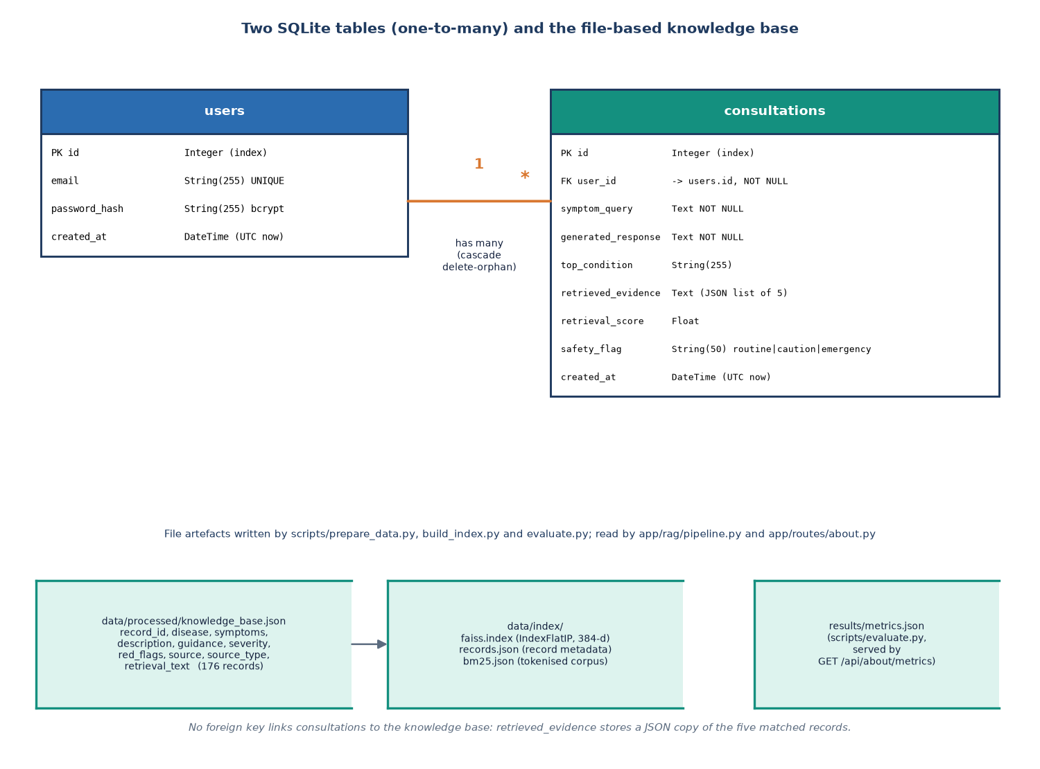
Figure 11: Entity-relationship diagram of the SQLite database and the retrieval stores.
Table 6: Table users
Column | Type | Constraint | Meaning
id | Integer | Primary key, indexed | User identifier
email | String(255) | Unique, indexed, not null | Sign-in name, stored in lower case
password_hash | String(255) | Not null | bcrypt hash of the password
created_at | DateTime | Default: current UTC time | Registration time

Table 7: Table consultations
Column | Type | Constraint | Meaning
id | Integer | Primary key, indexed | Consultation identifier
user_id | Integer | Foreign key to users.id, indexed, not null | Owner; every query filters on it
symptom_query | Text | Not null | The message as typed (3 to 2000 characters)
generated_response | Text | Not null | Answer text, with the emergency notice prepended when flagged
top_condition | String(255) | Default empty | Condition of the best-ranked record
retrieved_evidence | Text | Default '[]' | JSON list of the five evidence records with relevance
retrieval_score | Float | Default 0.0 | Displayed relevance of the best record (0 to 1)
safety_flag | String(50) | Default 'routine' | routine, caution or emergency
created_at | DateTime | Default: current UTC time | Time of the consultation

One user has many consultations (relationship with cascade 'all, delete-orphan'). The evidence is kept as a JSON string in one column rather than in a third table: a consultation is written once and read whole, so a join would add complexity without a benefit, and the stored evidence stays exactly as it was shown even if the knowledge base is rebuilt later. The cost is that the evidence cannot be queried with SQL; the history search is therefore done in Python on the latest 200 rows, over the question text and the top condition only.
The knowledge base is held in data/processed/knowledge_base.json and .csv with ten fields per record.
Table 8: Knowledge-base record
Field | Content
record_id | REC-0001 and so on
disease | Condition name
symptoms | Comma-separated, lower-case symptom list of this record
description | One-sentence description (shared by all records of a condition)
guidance | Self-care and when-to-seek-care text (shared by condition)
severity | low, moderate, high or emergency
red_flags | Warning signs that call for urgent care
source, source_type | Provenance label; every record carries source_type = synthetic
retrieval_text | 'Disease: ... Symptoms: ... Description: ... Guidance: ...' - the text that is embedded and indexed

1.6 Module Design
The backend has 800 non-blank lines of Python in 24 files; the React interface has 2820 lines of JavaScript and JSX. The table lists every backend module with its one responsibility.
Table 9: Backend modules
Module | Responsibility | Main interface
main.py | Creates the app, mounts the static files and routers, creates tables and the demo user at start-up, health route | app, GET /api/health
config.py | All settings, each overridable by a CARELENS_* environment variable | settings
database.py | Engine, session factory, init_db | get_db, init_db
models.py | ORM classes User and Consultation | User, Consultation
schemas.py | Pydantic request and response models with length limits | ChatRequest and others
auth.py | bcrypt hashing and JWT creation and decoding | hash_password, verify_password, create_token, decode_token
demo.py | Creates the demo account if missing | ensure_demo_user
routes/auth.py | Register, login, logout, me; require_user dependency (cookie or Bearer token) | /api/auth/*
routes/chat.py | Validates, runs the Pipeline, stores the consultation, maps errors to 400, 503 and 500 | POST /api/chat
routes/history.py | List with search, get one, delete; every query filtered by user_id | /api/history
routes/about.py | Serves results/metrics.json with the knowledge-base size | GET /api/about/metrics
routes/pages.py | Legacy server-rendered pages | /, /login, /dashboard ...
rag/pipeline.py | Lazy singleton that loads the models and indexes and runs the whole flow | get_pipeline, Pipeline.answer, rebuild
rag/query_expansion.py | Normalisation and the hypothetical-description template | normalize_query, expand_query_hyde
rag/embeddings.py | Sentence-transformer encoder with a TF-IDF fallback | EmbeddingBackend.encode
rag/faiss_store.py | Flat inner-product index: build, save, load, search | FaissStore
rag/bm25_store.py | BM25 index over the same records | BM25Store
rag/hybrid_retriever.py | Min-max normalised weighted fusion | fuse
rag/reranker.py | Cross-encoder rescoring and relevance normalisation | Reranker.rerank
rag/generator.py | Flan-T5 generation and the evidence-based fallback | Generator.generate
rag/safety.py | Emergency and caution rules, medication-phrase filter | check_safety, apply_safety_filter

Three design points follow from the table. First, the Pipeline is a lazy singleton: the three models take about a minute to load, so they are loaded on the first chat request and reused afterwards, which keeps start-up of the server immediate and the health route always available. Second, each RAG class hides one replaceable choice: swapping the vector store, the encoder or the generator means changing one file. Third, the safety module has no dependency on the retrieval classes, so a failure of any model cannot disable it.

1.6.1 The RAG classes in detail
EmbeddingBackend tries to load the sentence-transformer when it is created and records its mode, 'sentence-transformer' or 'tfidf'. In the first mode encode returns unit-length 384-dimensional vectors. In the second it fits, or re-uses, a TF-IDF vectoriser with at most 384 features and English stop words, pads or truncates the matrix to 384 columns and normalises the rows, so that the rest of the code does not need to know which mode is active. When the index is loaded from disk in TF-IDF mode, the vectoriser is refitted on the stored records.
FaissStore wraps a flat inner-product index. build adds the vectors and saves the index to data/index/faiss.index together with the record list in records.json; load restores both and returns false if either is missing, which makes the Pipeline rebuild; search returns up to k tuples of (score, record, position). BM25Store lower-cases the retrieval text, keeps alphanumeric tokens and builds a BM25Okapi model; it saves the records and the tokenised corpus as JSON so that the model can be rebuilt on load. Both stores index the same record list in the same order, which is what allows the fusion step to match their hits by position.
Reranker loads the cross-encoder when created. rerank scores every (query, retrieval text) pair, sorts by score, rescales the scores of all candidates to the 0 to 1 relevance and returns the best k. If the model is unavailable, or if prediction fails, the hybrid score takes the place of the cross-encoder score. Generator loads a text-to-text pipeline, builds the prompt of Section 6.3.6, and returns a pair of the answer and a label that says which method produced it: the model's name or 'evidence-fallback'. Pipeline creates one of each, ensures that the indexes exist, and exposes answer(raw_query, top_k), which returns one dictionary with the answer, the evidence list, the safety flag and message, the relevance label, the score, the generator label and the expansion that was used.
Table 10: Data passed between the stages
Stage output | Structure
Expansion | {normalized, hypothetical, combined} - three strings
Dense and lexical hits | List of (score, record, position) tuples, at most 15 each
Fused candidate | {idx, record, sem, lex, hybrid} - sorted by the hybrid score, at most 15
Reranked candidate | The fused dictionary plus rerank (raw score) and relevance (0 to 1), at most 5
Evidence item | {record_id, disease, symptoms, description, guidance, severity, red_flags, relevance, hybrid, rerank}; the route removes hybrid and rerank before sending
Safety result | {flag, message} with flag routine, caution or emergency
Pipeline result | {answer, top_condition, evidence, safety_flag, safety_message, relevance_label, retrieval_score, generated_by, expanded}

1.7 User Interface Design
The interface is a React single-page application built on a neo-brutalist component kit (thick borders, a grid background, a lime accent, Archivo Black headings and IBM Plex text). Routes are code-split with lazy loading. Signed-in pages are rendered in a shell with a side navigation that becomes a drawer on narrow screens; the public pages use a top bar. A guard component sends a visitor who is not signed in to the sign-in page and returns them to the page they asked for afterwards, and the sign-in and registration pages redirect a signed-in user to the assistant.
Table 11: Routes and screens
Route | Screen | What it offers
/ | Landing | Product pitch, how it works in steps, facts ticker, links to register or try the demo login
/login, /register | Sign in, Create account | Forms with inline errors and a show-password control
/assistant | Symptom assistant | Chat log, four example chips, text area (Enter sends), safety banners, answer, evidence cards, five recent consultations
/history | Consultations | Search box, sortable table with condition, safety badge, relevance and date, view and delete with confirmation
/history/:id | Consultation detail | Stored question, answer and evidence cards; delete
/about | About and metrics | The seven pipeline stages, the stored evaluation figures and the caveat that they come from synthetic data
* | Not found | Message and link home

Four design rules were applied. Safety is never decorative: an emergency notice is a full-width red alert above the answer, a caution notice is amber, and the line 'Not a diagnosis. In an emergency call your local emergency number' sits permanently under the text box. Evidence is visible: each answer is followed by cards that show the record's typical symptoms, description, guidance, severity badge, 'seek urgent care if' warning signs and a relevance bar, whose tooltip states that it is similarity to a record and not a medical probability. Every state is designed: loading skeletons, empty states, error states with a retry button, toasts for success, and a typing indicator while the answer is computed. Accessibility basics are in place: the conversation is an aria-live log, controls have labels, dialogs trap focus and close with Escape, the theme (light or dark) is stored in the browser, and animations respect the reduced-motion setting.
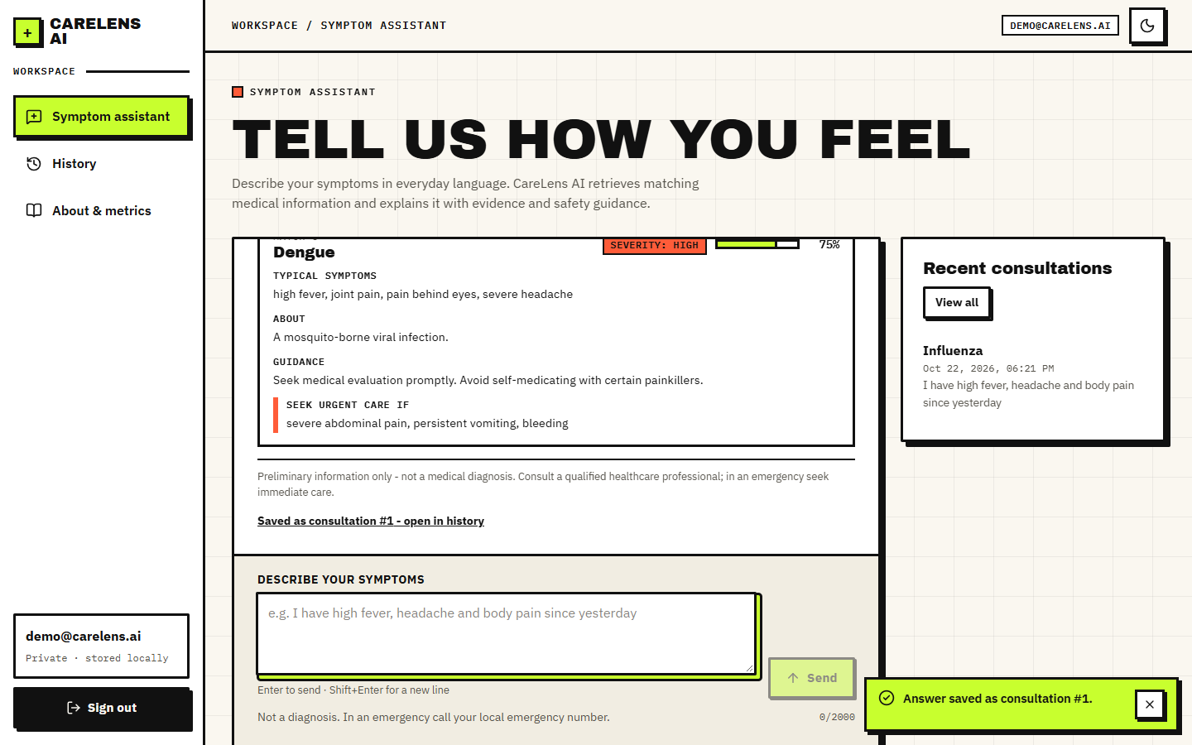
Figure 12: Evidence cards under an answer: symptoms, description, guidance, severity, urgent-care warning and relevance.
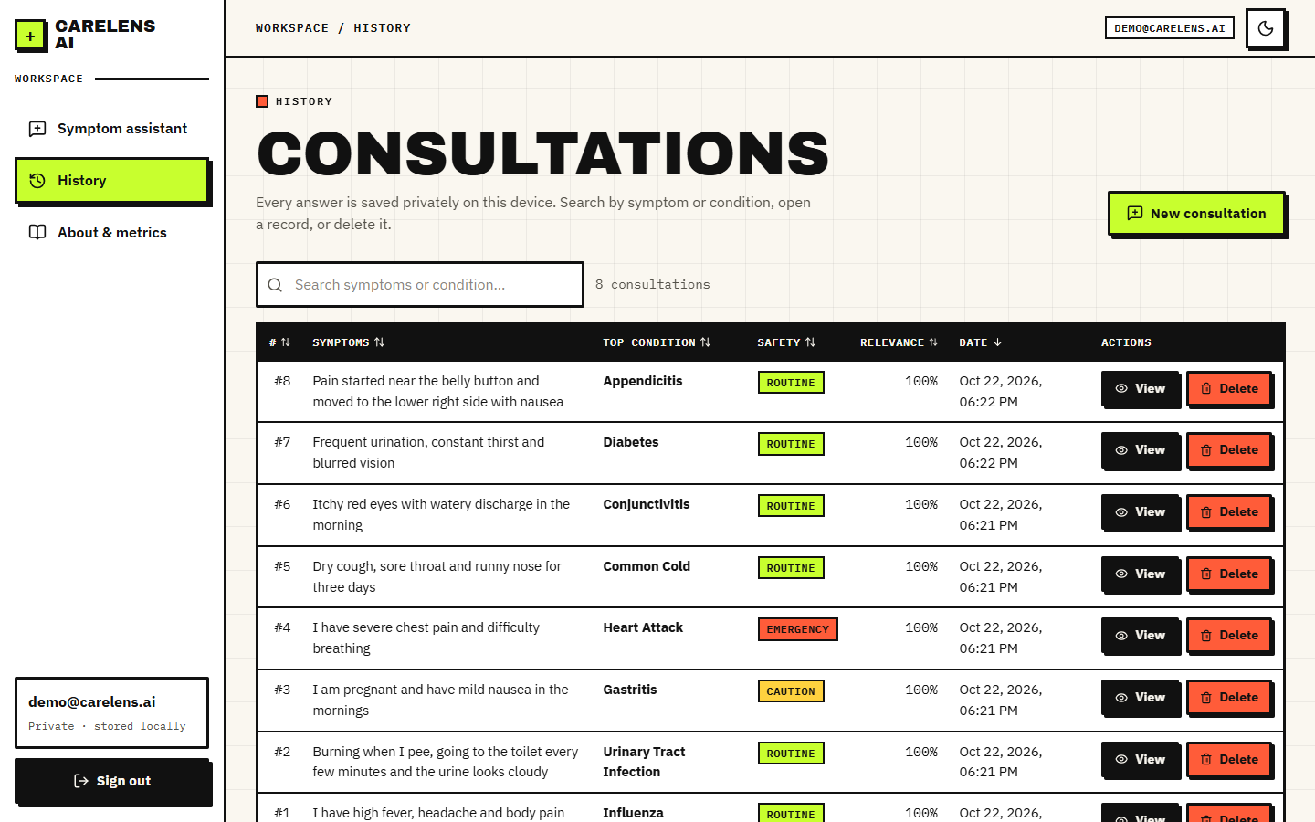
Figure 13: History screen with search, safety badges and relevance.
Screens captured from the running application are shown with their analysis in Chapter 8.

1.8 Design Decisions and Their Reasons
Each decision below was made while the system was built, with the alternative that was not taken and the consequence that has since been observed.
Table 12: Design decisions
Decision | Alternative | Reason | Observed consequence
Run every model locally | Hosted LLM API | Symptom text is health data; no cost, key or internet needed | First request takes about a minute to load models; CPU generation is slow
Hybrid dense + lexical retrieval | Dense only | Symptom words are short and exact; BM25 catches literal matches, the encoder catches paraphrase | Hybrid 90% vs dense 90% on lay probes; BM25 alone 88%
Cross-encoder reranking of 15 candidates | Return the fused order | A cross-encoder reads query and record together and is more precise | Top-1 on lay probes 96.7% vs 90.0%; reranking is the slowest stage
Rule-based HyDE-style template | LLM-written hypothetical document | No second model call and no latency; deterministic | No measured gain: top-1 without it 100.0% on lay probes
Min-max fusion with weights 0.65/0.35 | Reciprocal rank fusion | Keeps score magnitudes; weights are configurable | Weights were not tuned on data
Relevance = min-max of rerank scores | Raw cross-encoder score or probability | Gives the user a simple 0 to 100% bar | The best record is always 100%, even for complaints outside the knowledge base (Chapter 8)
Answer from retrieved records, with a deterministic fallback | Free generation | Nothing may be said that is not in the evidence | Fallback text is repetitive; the local generator path echoes its prompt in the tested environment
Regex safety layer separate from retrieval | Classifier or LLM triage | Transparent, instant, cannot be disabled by a model failure | Misses paraphrased emergencies and fires on negations (Chapter 7)
Evidence stored as JSON text | Separate evidence table | Written once and read whole; keeps what was shown | Not searchable with SQL
JWT in an httponly cookie, Bearer also accepted | Token in local storage | Not readable by page scripts | No Secure flag and a default signing key (Chapter 7)
SQLite | PostgreSQL | Single file, no server | Suited to one machine, not to many users
Vite dev server proxies /api | Cross-origin requests with CORS | Same origin, so the cookie works without CORS configuration | Docker uses nginx for the same purpose

1.9 Quality Attributes and Design Constraints
The design was judged against five quality attributes, each with the measure that was actually used and the constraint that limits it.
Table 13: Quality attributes
Attribute | How the design addresses it | Constraint or open point
Privacy | Local models, local SQLite file, no analytics, no external calls after the first model download, per-user filtering of every query | Data are not encrypted at rest; the signing key is a default value unless changed
Safety | Rule layer independent of retrieval, permanent disclaimer, emergency banner above the answer, medication-phrase filter | Rules are literal; they do not understand paraphrase or negation
Reliability | Three degradation paths; 503 and 500 mapped to readable messages; retry button in the interface | A model that loads but misbehaves (the generator echo) is not detected
Performance | Models loaded once; exact search over a small index; stages timed separately | The cross-encoder on a CPU dominates the response time; no concurrency design
Maintainability | One module per replaceable choice; settings in one file with environment overrides; no global state besides the Pipeline singleton | The test suite is small; behaviour of the safety and history code is mostly covered by the smoke test and probes
Portability | Windows launcher, manual steps for other systems, Docker images for the API and the web server | Tested only on Windows 11

Two constraints shaped many choices. The hardware is an ordinary laptop or desktop without a GPU, which ruled out a large generator and made the small Flan-T5 and the six-layer cross-encoder the practical choices. The knowledge base is small and written by the team, which made an exact flat index sufficient and made the retrieval question easy; a real clinical corpus of thousands of passages would need the structure that the base paper and the ClinicBot system [6] describe, such as sectioned guidelines with provenance, and would justify an approximate index.

2. IMPLEMENTATION

2.1 Application Architecture and Implementation
Table 14: Configuration of the pipeline (app/config.py; each value can be overridden by a CARELENS_* environment variable)
Parameter | Value
Embedding model | sentence-transformers/all-MiniLM-L6-v2
Reranker | cross-encoder/ms-marco-MiniLM-L-6-v2
Generator | google/flan-t5-small
Candidate pool per retriever / records returned | 15 / 5
Fusion weights (dense, lexical) | 0.65, 0.35
Message length | 3 to 2000 characters
Token lifetime | 1440 minutes (24 h)
Database | data/carelens.db (SQLite)

The backend is a FastAPI application served by Uvicorn on port 8412. At start-up it creates the tables and the demo user; it does not load any model. The first call to POST /api/chat creates the Pipeline singleton, which loads the sentence-transformer, the cross-encoder and the generator and the two indexes; in the measurement environment this took about 62 seconds, and later requests reuse the loaded objects. If the index files are missing the Pipeline rebuilds them from the knowledge base before it answers. Every route obtains a database session from the get_db dependency and closes it after the response.
The frontend is a React application served by Vite on port 5412. State is kept in components and in one authentication context; there is no global store. The API client lib/api.js adds credentials to every request, converts network failures and error responses into an ApiError with a readable message, and fires an 'unauthorized' event on a 401 so that an expired session sends the user to the sign-in page. The Vite server proxies every /api path to the backend, so the browser sees one origin and the cookie works without cross-origin configuration; in Docker the same job is done by an nginx container.
Four details of the interface code are worth recording. The authentication context keeps a small hint in browser storage that records whether a session may exist, because the session cookie is httponly and cannot be read by the page; without the hint the application would call /api/auth/me on every first visit and log an expected 401. The assistant page keeps the conversation in component state, aborts an unfinished request when the user leaves the page, and shows a toast with the consultation number when an answer is saved. The history page sends the search text to the server after a delay of 300 ms, so a request is not made for every keystroke, and asks for confirmation before it deletes. Every page sets its own document title, and every list has a loading, an empty and an error state.
Table 15: Main software components and versions in the measurement environment
Component | Version | Used for
Python | 3.11.9 | Backend and scripts
FastAPI / SQLAlchemy | 0.159.1 / 2.1.6 | API and database access
PyTorch (CPU) / Transformers | 2.14.1+cpu / 5.20.2 | Model execution; the Transformers version removed the task the generator needs
sentence-transformers / FAISS | 6.2.0 / 1.15.1 | Embeddings and cross-encoder; vector index
scikit-learn | 1.9.1 | TF-IDF fallback and evaluation metrics
React / Vite | 19 / 8 (package.json) | Single-page application and dev server

2.2 API Design
The API is JSON over HTTP. Errors always have the form {detail: message}; validation errors from Pydantic return 422 with a list of messages that the client joins into one sentence. Sign-in is by an httponly cookie named carelens_token; an Authorization: Bearer header is also accepted, which the tests use.
Table 16: API endpoints
Method and path | Auth | Request | Success response | Errors
GET /api/health | no | - | {status, product} | -
POST /api/auth/register | no | {email, password 6-128} | {email, token} + cookie | 400 e-mail exists; 422
POST /api/auth/login | no | {email, password} | {email, token} + cookie | 401 invalid; 422
POST /api/auth/logout | no | - | {ok}, cookie cleared | -
GET /api/auth/me | cookie | - | {email, id} | 401
POST /api/chat | yes | {query 3-2000} | {answer, top_condition, evidence[5], safety_flag, safety_message, relevance_label, consultation_id, created_at, generated_by} | 400 blank; 401; 422; 503 knowledge base missing; 500
GET /api/history?search= | yes | optional search text | list of up to 200 consultations, newest first | 401
GET /api/history/{id} | yes | - | one consultation | 401; 404 not found or not yours
DELETE /api/history/{id} | yes | - | {ok} | 401; 404
GET /api/about/metrics | no | - | stored metrics + kb_records, kb_conditions, data_source | 404 metrics file missing

A 404 rather than a 403 is returned when a consultation exists but belongs to another user, so that the existence of other users' records is not revealed.

2.3 Security and Error Handling
Passwords are hashed with bcrypt [32] with a random salt before storage, and verification catches malformed hashes and returns false. A successful sign-in creates a JSON Web Token [33] signed with HMAC-SHA256 that holds the user id, the e-mail and an expiry after 1440 minutes, and sets it as an httponly cookie with SameSite=lax. Every history route filters on the user id of the token, and a message is accepted only between 3 and 2000 characters. The chat route separates three failure causes: a missing knowledge base returns 503 with the name of the missing file, any other pipeline error returns 500 with a generic message and prints the detail to the server log, and a failure while saving returns 500 after a rollback. The interface turns each of these into a message in the conversation with a retry button.
Three weaknesses are known and are tested in Chapter 7: the signing key has a built-in default value, 'carelens-local-dev-secret-change-me', that is used unless CARELENS_SECRET_KEY is set; the cookie has no Secure flag, which matters when the application is served over HTTPS; and there is no limit on failed sign-in attempts. The registration route also reveals whether an e-mail is already registered. The application was designed for one machine and is not hardened for a public deployment.

2.4 Installation and Execution
The project runs on Windows with Python 3.10 or newer and Node.js 18 or newer. The simplest way is to double-click run.bat in the project folder. The launcher reads the ports from .env (backend 8412, frontend 5412), creates a virtual environment if there is none, installs the Python requirements, prepares the knowledge base and the index when they are missing, installs the frontend packages, seeds the demo account, opens two server windows (CareLens API and CareLens Web) and opens the browser at http://localhost:5412. The first start downloads the three models from Hugging Face and takes longer; later starts need only the time to load the models at the first message.
• Demo login: demo@carelens.ai / Demo@1234; the account is created automatically and has sample consultations.
• Docker: docker compose up --build builds the React app, runs the API container and an nginx container on the same ports.
• Manual: python -m venv .venv; pip install -r requirements.txt; python scripts/prepare_data.py; python scripts/build_index.py; python scripts/seed_demo.py; python -m uvicorn app.main:app --port 8412; then npm install and npm run dev in frontend/.
• Checks: python -m pytest tests (unit and API tests), python scripts/smoke_test.py (end-to-end through the web port) and python scripts/capture_screens.py (screenshots).
• Offline mode: if a model cannot be downloaded the application falls back to TF-IDF retrieval and evidence-based answers and continues to work.

3. KEY CODE WALK-THROUGHS
The excerpts below are copied from the repository in the state in which the results were measured. Each is followed by the reason it is written the way it is.

3.1 Query expansion (`app/rag/query_expansion.py`)
def expand_query_hyde(raw_query: str) -> dict:
"""Return {'normalized': str, 'hypothetical': str, 'combined': str}."""
norm = normalize_query(raw_query)
# Extract mention-like fragments (split on commas/periods/and)
frags = [f.strip() for f in re.split(r"[,.]| and | with ", norm) if f.strip()]
frags = [f for f in frags if len(f) > 1][:8]
core = ", ".join(frags) if frags else norm
hypothetical = (
f"Medical symptom presentation involving {core}. "
"Patient-reported symptoms with possible associated systemic features, "
"onset information and relevant clinical observations for matching medical information."
)
combined = f"{norm} {hypothetical}"
return {"normalized": norm, "hypothetical": hypothetical, "combined": combined}

The user's text is lower-cased and split on commas, full stops, "and" and "with" into at most eight fragments. A fixed sentence wraps them as a "hypothetical" description, and the combined string is what both retrievers receive. The method needs no model and no network, which is why it was chosen; the ablation shows it adds nothing measurable.

3.2 Score fusion (`app/rag/hybrid_retriever.py`)
def fuse(sem_hits, lex_hits, w_sem: float = 0.65, w_lex: float = 0.35, k: int = 15):
"""sem_hits / lex_hits: list of (score, record, idx). Returns ranked list of dicts."""
sem_scores = {idx: s for s, _, idx in sem_hits}
lex_scores = {idx: s for s, _, idx in lex_hits}
rec_by_idx = {}
for _, r, idx in list(sem_hits) + list(lex_hits):
rec_by_idx[idx] = r
all_idx = list(rec_by_idx.keys())
sv = _minmax([sem_scores.get(i, 0.0) for i in all_idx])
lv = _minmax([lex_scores.get(i, 0.0) for i in all_idx])
fused = []
for i, a, b in zip(all_idx, sv, lv):
fused.append({"idx": i, "record": rec_by_idx[i],
"sem": sem_scores.get(i, 0.0), "lex": lex_scores.get(i, 0.0),
"hybrid": w_sem * a + w_lex * b})
fused.sort(key=lambda d: d["hybrid"], reverse=True)
return fused[:k]

FAISS inner products and BM25 scores live on different scales, so each is min-max normalised over the candidates before the weighted sum. A record found by only one retriever scores 0 on the other. The weights 0.65 and 0.35 are configuration values; they were not tuned in this project.

3.3 Reranking and the displayed relevance (`app/rag/reranker.py`)
def rerank(self, query: str, candidates: list[dict], top_k: int = 5):
if not candidates:
return []
if self.available and self.model is not None:
try:
pairs = [(query, c["record"].get("retrieval_text", "")) for c in candidates]
scores = self.model.predict(pairs)
for c, s in zip(candidates, scores):
c["rerank"] = float(s)
candidates = sorted(candidates, key=lambda d: d["rerank"], reverse=True)
except Exception as e:
print(f"[reranker] predict failed: {e}")
for c in candidates:
c["rerank"] = float(c.get("hybrid", 0.0))
else:
for c in candidates:
c["rerank"] = float(c.get("hybrid", 0.0))
# normalize rerank to 0..1 for display
vals = [c["rerank"] for c in candidates]
lo, hi = min(vals), max(vals)
for c in candidates:
c["relevance"] = 1.0 if hi - lo < 1e-9 else (c["rerank"] - lo) / (hi - lo)
return candidates[:top_k]

The cross-encoder scores each query-record pair. The lines at the end rescale the scores of the candidates to 0 to 1 for display; because the lowest and highest candidates become exactly 0 and 1, the top record is always 100%, which is the cause of the constant relevance display measured in Chapter 8. Showing the raw score, or a threshold on it, would preserve the uncertainty.

3.4 The pipeline (`app/rag/pipeline.py`)
def answer(self, raw_query: str, top_k: int | None = None) -> dict:
top_k = top_k or settings.RETRIEVAL_TOP_K
exp = expand_query_hyde(raw_query)
combined = exp["combined"]
qvec = self.embeddings.encode([combined])[0]
sem_hits = self.faiss.search(qvec, k=settings.CANDIDATE_K)
lex_hits = self.bm25.search(combined, k=settings.CANDIDATE_K)
fused = fuse(sem_hits, lex_hits, settings.HYBRID_SEMANTIC_WEIGHT,
settings.HYBRID_LEXICAL_WEIGHT, k=settings.CANDIDATE_K)
ranked = self.reranker.rerank(combined, fused, top_k=top_k)
evidence = []
for c in ranked:
r = c["record"]
evidence.append({
"record_id": r.get("record_id", ""),
"disease": r.get("disease", ""),
"symptoms": r.get("symptoms", ""),
"description": r.get("description", ""),
"guidance": r.get("guidance", ""),
"severity": r.get("severity", ""),
"red_flags": r.get("red_flags", ""),
"relevance": round(float(c.get("relevance", 0.0)), 3),
"hybrid": round(float(c.get("hybrid", 0.0)), 4),
"rerank": round(float(c.get("rerank", 0.0)), 4),
})
safe = safety_mod.check_safety(raw_query)
answer, gen_by = self.generator.generate(exp["normalized"], ranked)
answer = safety_mod.apply_safety_filter(answer)
if safe["flag"] == "emergency":
answer = safe["message"] + "\n\n" + answer
top_condition = evidence[0]["disease"] if evidence else ""
score = float(evidence[0]["relevance"]) if evidence else 0.0
# user-friendly relevance label
if score >= 0.66:
label = "Strong match"
elif score >= 0.33:
label = "Moderate match"
else:
label = "Weak match"
return {
"answer": answer,
"top_condition": top_condition,
"evidence": evidence,
"safety_flag": safe["flag"],
"safety_message": safe["message"],
"relevance_label": label,
"retrieval_score": score,
"generated_by": gen_by,
"expanded": exp,
}

answer strings the stages together: expansion, embedding, the two searches, fusion, reranking, evidence assembly, safety check, generation, the answer filter and, for emergencies, a prepended notice. The label bands 0.66 and 0.33 are applied to the rescaled score. The pipeline is a lazily created singleton, so the models load once, on the first request.

3.5 Safety rules (`app/rag/safety.py`)
def check_safety(query: str) -> dict:
q = (query or "").lower()
for pattern, advice in EMERGENCY_PATTERNS:
if re.search(pattern, q):
return {
"flag": "emergency",
"message": (f"Emergency safety notice: {advice} Please seek urgent/emergency medical care "
"right away (local emergency number or nearest emergency department). " + DISCLAIMER)
}
# high-risk single keywords that merit caution banner
cautious = ["chest pain", "breathing", "bleeding", "pregnant", "infant", "newborn"]
if any(k in q for k in cautious):
return {"flag": "caution",
"message": ("Caution: your message mentions potentially serious symptoms. "
"Consider contacting a healthcare professional promptly. " + DISCLAIMER)}
return {"flag": "routine", "message": DISCLAIMER}

def apply_safety_filter(answer: str) -> str:
banned = ["take ibuprofen", "take antibiotics", "dosage", "prescribe", "mg twice daily"]
text = answer
for b in banned:
if b.lower() in text.lower():
text = text.replace(b, "[removed: specific medication instruction]")
return text

Ten regular expressions map wording to an emergency advice sentence; six keywords raise a caution. The rules are fast and transparent and can be read by a clinician, but they match words, not meaning: negation, history and paraphrase are outside their reach. In the filter, detection lower-cases the text while the replacement does not, so a capitalised phrase is detected and left in place.

3.6 Answer generation and its fallback (`app/rag/generator.py`)
def generate(self, query: str, evidence: list[dict]) -> tuple[str, str]:
"""Returns (answer, generated_by)."""
if self.available and self.pipe is not None:
try:
out = self.pipe(self._prompt(query, evidence), max_new_tokens=220, do_sample=False)
text = out[0]["generated_text"].strip() if out else ""
if not text:
raise RuntimeError("empty generation")
# safety post-check: strip any definitive-diagnosis phrasing
text = text.replace("You have ", "Information most closely associated with ")
if "not a diagnosis" not in text.lower():
text += " This information is not a diagnosis; consult a qualified healthcare professional."
return text, f"local-generator:{self.model_name}"
except Exception as e:
print(f"[generator] generation failed: {e}")
return self.fallback_answer(query, evidence), "evidence-fallback"

If a model is loaded its output is post-processed ("You have" is reworded, a disclaimer is appended when missing). Any failure drops to the deterministic text built from the evidence. In the measured environment the model task silently becomes text-generation and the output equals the prompt; because the code treats any non-empty text as success, the failure is not detected.

3.7 The chat route and its guards (`app/routes/chat.py`)
@router.post("/chat")
def chat(payload: ChatRequest, user=Depends(require_user), db: Session = Depends(get_db)):
q = (payload.query or "").strip()
if not q:
raise HTTPException(status_code=400, detail="Please describe your symptoms.")
if len(q) > settings.MAX_QUERY_CHARS:
raise HTTPException(status_code=400, detail=f"Input too long (max {settings.MAX_QUERY_CHARS} characters).")
try:
from app.rag.pipeline import get_pipeline
pipe = get_pipeline()
result = pipe.answer(q)
except FileNotFoundError as e:
raise HTTPException(status_code=503, detail=f"Medical knowledge base not ready: {e}")
except Exception as e:
print(f"[chat] pipeline error: {e}")
raise HTTPException(status_code=500, detail="The assistant is temporarily unavailable. Please try again.")
try:
c = Consultation(
user_id=user.id,
symptom_query=q,
generated_response=result["answer"],
top_condition=result.get("top_condition", ""),
retrieved_evidence=json.dumps(result.get("evidence", [])),
retrieval_score=float(result.get("retrieval_score", 0.0)),
safety_flag=result.get("safety_flag", "routine"),
)
db.add(c)
db.commit()
db.refresh(c)
except Exception as e:
db.rollback()
print(f"[chat] db error: {e}")
raise HTTPException(status_code=500, detail="Could not save consultation.")
ev = [{"record_id": e["record_id"], "disease": e["disease"], "symptoms": e["symptoms"],
"description": e["description"], "guidance": e["guidance"], "severity": e["severity"],
"red_flags": e["red_flags"], "relevance": e["relevance"]} for e in result["evidence"]]
return {
"answer": result["answer"],
"top_condition": result["top_condition"],
"evidence": ev,
"safety_flag": result["safety_flag"],
"safety_message": result["safety_message"],
"relevance_label": result["relevance_label"],
"consultation_id": c.id,
"created_at": c.created_at.isoformat() if c.created_at else "",
"generated_by": result["generated_by"],
}

The route requires a signed-in user, rejects empty or over-long input, runs the pipeline, stores the consultation for that user only and returns the evidence fields the interface needs. A missing knowledge base returns 503; any other failure returns a generic 500 message without internals.

4. IMPLEMENTATION DECISIONS AND THEIR REASONS

4.1 Decisions and reasons
Table 17: Implementation decisions
Decision | Reason | Cost or alternative
Hybrid of FAISS and BM25 | Symptom phrases are short; word overlap and meaning both help, and fusion is cheap | Weights untuned; BM25 alone is nearly as good on this data
Cross-encoder rerank on 15 candidates | Reads query and record together and fixes ordering among close candidates | About 555 ms per query on a CPU
MiniLM sentence model (384-d) | Small, fast on CPU, widely used [18, 24] | Not medical-domain; a biomedical encoder could do better
Flat FAISS index | 176 vectors; exact search costs microseconds | Would need an approximate index at millions of records
Rule-based expansion | No model or network; deterministic | Measured no gain; an LLM-based HyDE would cost latency
Flan-T5-small with a template fallback | Runs on a CPU; the fallback guarantees an answer and structural grounding | Echo defect with transformers 5; template text is repetitive
Regex safety rules | Transparent, instant, clinician-readable | Blind to paraphrase and negation
SQLite + SQLAlchemy | Zero-setup local storage, per-user rows | Single-writer; fine for one machine
bcrypt and JWT in an httponly cookie | Slow salted hashing [32]; token not readable by page scripts [33] | Default signing key must be replaced for shared use
React + Vite frontend with a proxy | Single origin for cookies; modern, responsive interface | Needs Node.js on the machine
Local-only processing | Health text is private; no paid API | Models must be downloaded once

